NAMDET Bursary / Award 2019
Each NAMDET Bursary is provided for NAMDET Members ONLY and can be used to help develop training, new research projects, implement new training strategies, attendance at a conference or course but MUST relevant to at least one of the 5 key aims and objectives of NAMDET
Name
Job Title:
Employer
NAMDET Regional Group | Wales [ ] London & SE [ ] Yorkshire/Humberside [ ] West Midlands [ ]  South West [ ] North East [ ] NorthWest [ ] Scotland [ ] Ireland [ ] Other [ ]__________________

Employer Address
Postcode:
Telephone:
E-mail:
How did you hear about this Bursary/Award?: (list all that apply)

NAMDET Website [ ] MDET Journal [ ] Direct email [ ] NAMDET Newsletter [ ]
Regional Meeting [ ] NAMDET Conference [ ] Other [ ] ______________________________

The case for support Please indicate the key NAMDET objectives that apply to your application;
- Raise the status and standing of Medical Device Trainers and Educators [ ]
- Provide a forum for mutual support and assistance between members [ ]
- Represent the consensus views and opinions of members at regional and national level [ ]
- Inform and improve national policy and the regulatory landscape by communicating NAMDET member positions on issues of importance [ ]
- Positively contribute to reducing adverse medical device incidents [ ]
TITLE:
Please outline your project below, including a background to the issues at hand, how you intent to help address these and or how the bursary will benefit NAMDET, you and your employer.

Statement of support from the Head of Department or equivalent

Title ……………………… Name ……………………………………………………………………………….

Designation………………………………………………………………………………………………………
Statement of Support (must include how the Bursary will benefit NAMDET, applicant ant the employer)

Signed : ……………………………………………………. Date: …………………………………………

List the references, research, reports etc. which support your application.
Funding Requirement
Indicate total funds applied for (Max. £500) including details of the costs for each element
Expenditure | Total
 | £
 | £
 | £
 | £
 | £
 | £
 | £
 | £

Value granted by NAMDET | £

Applicant’s Declaration;

I confirm that the details given above are correct to the best of my knowledge.

Applicant’s Signature ____________________________ Date ________________________

Please return, with any additional supporting papers you wish to submit to:
Paul T. Lee, Chairman NAMDET
paul.lee@namdet.org

Supportive Information: NAMDET Bursary / Award 2019
Rules that apply;
- The NAMDET Bursary / Award is open to NAMDET members ONLY.
- The award is not intended to fund part or partial fees for academic qualifications.
- The award provides funds for attendance at a conference or course, training initiative, education project or proposal relevant to the work of the candidate, in the UK or abroad.
- The project must benefit NAMDET, the applicant and their employer.
- The project must relate to at least one of the 5 key aims and objectives of NAMDET.
- Applicants must complete all sections of the application form.
- Funds MUST be used by 31st December of the year applied for.
- The recipient of the bursary will acknowledge financial support from NAMDET in any articles, journal entry or presentation made.
- Successful applicants agree to present at NAMDET regional meetings and/or write a summary article for MDET journal.
- Applications can be made at any time.
- There will be up to 2 Bursaries awarded each year and up to £500 can be applied for.
- In special circumstances additional award/s may be made if NAMDET agree the project deserves consideration
- Applicants are restricted to 1 bursary application per annum

Application
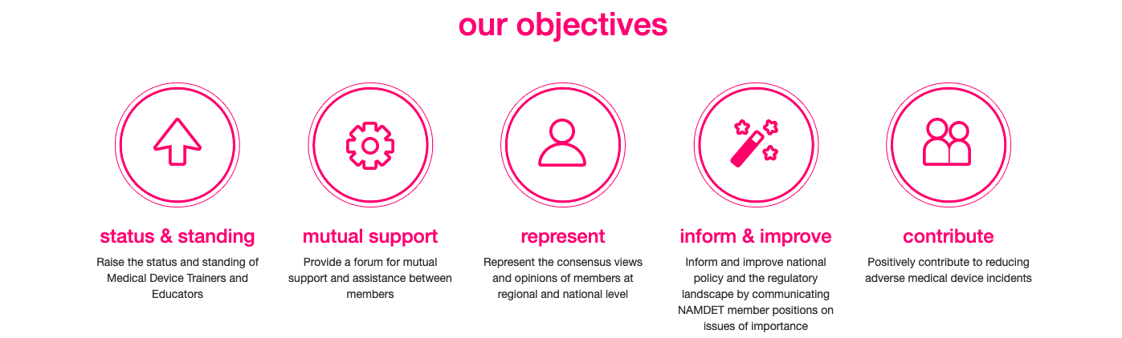
- The following costs are allowable; economy travel making full use of advance tickets, accommodation, registration at a conference if relevant. Subsistence costs -if not provided. Materials and software, devices and equipment etc.
- The candidate should include a robust justification for attendance, such as evidence that an abstract has been submitted or a clear description of the educational/professional development benefit.
- Fill in the form providing the following details (as appropriate)
- Details of the project/conference or course to be attended.
- Identified devices, equipment and or software required for project
- An outline of the issues at hand and how the bursary will help address some of the key NAMDET objectives
- Signed statement from Head of Department that they support application
- Full breakdown of costs with details rather than rough estimated costs.

4. The NAMDET management board will receive applications and make the final decision concerning any award.

Criteria against which the application will be assessed

- Has a sufficient case been made that funding will benefit NAMDET, the applicant and the employer?
- Does the application align to NAMDET’s key objectives?
- Is the employer supportive?
- Is the funding justifiable and reasonable?

Equality and Diversity

NAMDET will not discriminate either directly or indirectly because of age, disability, gender reassignment, marriage and civil partnership, pregnancy and maternity, race (including colour, nationality and ethnic or national origins), religion or belief, sex or sexual orientation.

