NAMDET Ltd
30 Aston End Road,
Aston Village
Stevenage.
Hertfordshire.
SG2 7EU

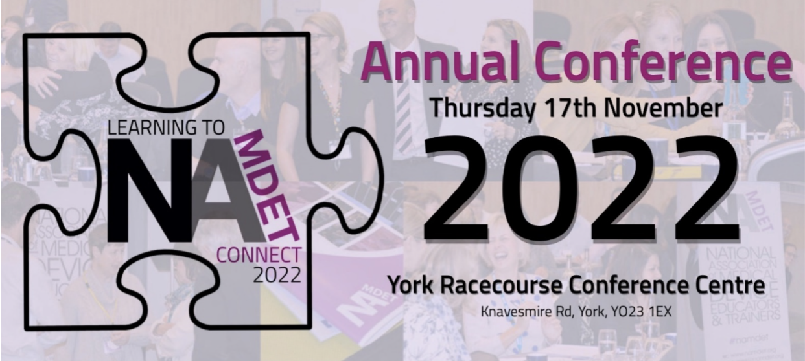
REQUEST FOR AN INVOICE FOR THE 2022 NAMDET CONFERENCE

Dear NAMDET colleague,
If you would like to receive an invoice, then please fill in the form below and email to john.byrne@namdet.org
- The cost of the conference is £65:00 for members, £85 for non members
- The cost of the networking Dinner is £25:00
- The cost to attend both the Conference and the Networking Dinner is £110 for non-member and £90 for a member
 | Name | Member Yes / No | Billing Address | Phone Number | Email | Trust/ Company | Networking Dinner. 16th Nov. (Y/N) | Dietary Requirements  (Y/N). Please state | Consent to share data (Y/N)
1
2

Thank you,
NAMDET Team. www.namdet.org

