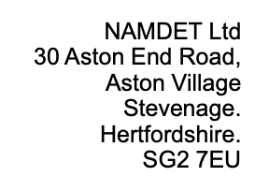
REQUEST FOR AN INVOICE FOR THE 2023 NAMDET NATIONAL CONFERENCE

Dear NAMDET colleague,
If you would like to receive an invoice, then please fill in the form below and email to john.byrne@namdet.org
The cost per delegate is £65:00 for conference or £95 for conference + dinner
 | Delegate Name  (For badge) | Billing Address | Phone Number | Email | Trust/ Company | Event Ticket £65 | Event plus Dinner (£95) | Special Dietary Requirements Please state | Consent to share data (Y/N) | Total
1
2
3
4

Please add rows as required
Thank you, NAMDET Conference Team. www.namdet.org

