**NAMDET Conference 2023,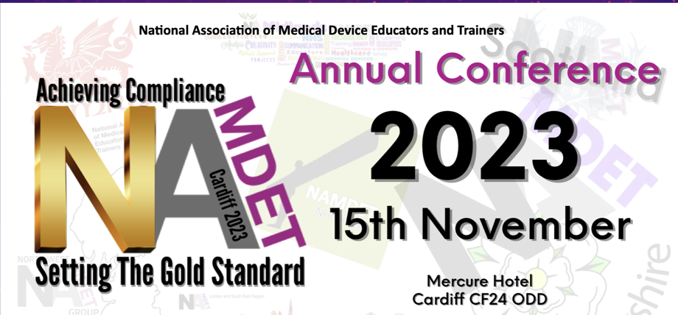 poster competition.**

Do you have a project, training programme or safety system that you have been involved in designing, developing or implementing and want to share the success story with your NAMDET colleagues?

Why not complete the application form below and send to the conference team and get it presented at the NAMDET national conference in Cardiff, November 15th 2023.

All successful poster submissions will be shown at conference.  Authors of the **two posters judged to be the best** will be invited to present their work at the main conference presentation session. These two successful candidates will also be able to claim a bursary of up to £250 to help towards conference fees and travel costs.

Please complete as many sections as possible and keep to approx 250-300 words

***Example poster pro-forma and guidance***

|  |  |
| --- | --- |
| **Title** | Should be a clear and concise statement of the work/project/study |
| **Author/s** | Surname, followed by initials |
| **Affiliations** | Employer details |
| **Lead author email** | State the same email for all correspondences |
| **Purpose**  Purpose is a statement of the reason for conducting a project or reporting on a program, process or activity.  **Methods**  Briefly describe the methods of the project to define the data or population, outcome variables, and analytic techniques, as well as data collection procedures and frequencies.  **Results**  The results should be stated succinctly to support only the purpose, objectives, hypothesis, or conclusions.  **Conclusions**  The conclusion(s) should highlight the impact of the project, and follow the methods and results in a logical fashion. This section should not restate results. New information or conclusions not supported by data in the results section should be avoided.  **Citations/references**  Use this section to add in any national guidelines, papers, references or articles used. | |

Closing Date for all submissions in **September 30th 2023** see [www.namdet.org](http://www.namdet.org) for conference details

Email all final poster competition submissions to [paul.lee@namdet.org](mailto:paul.lee@namdet.org)