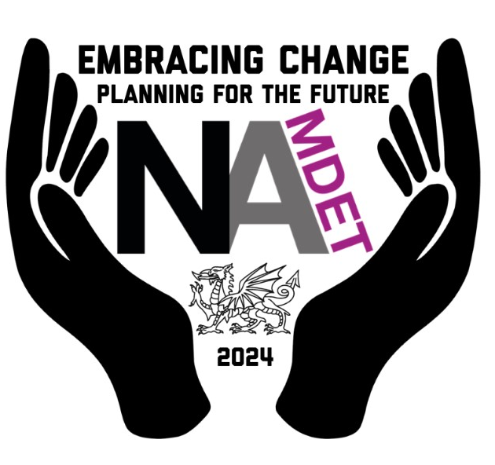
NAMDET Annual Conference, Llandudno November 13th 2024

Poster competition.
Do you have a project, training programme, new course, or safety system that you have been involved in designing, developing or implementing and want to share the success story with your NAMDET colleagues?
Why not submit an abstract describing your anticipated poster, sending it to the conference team judging panel and get it shown or presented at the NAMDET national conference in Llandudno, November 13th 2024.
All successful poster submissions will be shown at conference. Authors of the two posters judged to be the best will be invited to present their work at the main conference presentation session. These two successful candidates will also be able to claim a bursary of up to £250 to help towards conference fees and travel costs.
For your abstract, please use the table below as a template, providing 200-400 words in total, for the purpose, methods, results and conclusions.
Title | Should be a clear and concise statement of the work/project/study
Author/s | Surname/s, followed by initials
Affiliations | Employer details
Lead author email | State the same email for all correspondences
Purpose
Purpose is a statement of the reason for conducting a project or reporting on a program, process or activity.
Methods
Briefly describe the methods of the project to define the data or population, outcome variables, and analytic techniques, as well as data collection procedures and frequencies. For service improvement projects, define the linked unmet need and the process methodology.
Results
The results should be stated succinctly to support only the purpose, objectives, hypothesis, or conclusions.
Conclusions
The conclusion(s) should highlight the impact of the project summarising the takeaway learning, and follow the methods and results in a logical fashion. This section should not restate results. New information or conclusions not supported by data in the results section should be avoided.
Citations/references
Use this section to add in any national guidelines, papers, references or articles used. (The word count does not include reference used etc.)

Important dates;
Closing date for all submissions 4th August 2024
Notification of successful poster submission (to be displayed at conference) 2nd September 2024
Two best submissions announced to present their work at conference 2nd September 2024 (and winners of £250 bursary)
Email all poster competition submissions to richard.stubbs@wales.nhs.uk
Thank you,
Tracie Walkden Williams, Coordinator NAMDET Conference 2024.

