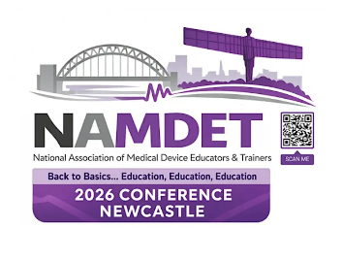
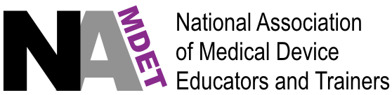

NAMDET Annual Conference, Newcastle, November 12th, 2026

Poster Abstract Competition.

Do you have a project, training program, new course, or safety system that you have been involved in designing, developing or implementing that links with the conference theme, and want to share the success story with your NAMDET colleagues?

Why not submit an abstract describing your anticipated poster, send it to the Poster and Awards Judging Panel and get it displayed at the NAMDET national conference in Newcastle on 12th November 2026.

Authors of the abstracts accepted will be invited to have their poster displayed at the conference poster sessions, and of they are attending the conference, they will have the opportunity to showcase their poster in person.

The top two judged poster authoring teams will be awarded a prize of £250 per team with the expectation that they will attend in person to present a talk on the work behind their posters within the main conference programme. Please note that decisions made by the Poster and Awards Judging Panel are final.

For your abstract, please use the table below as a template, providing 300-500 words in total, for the purpose, methods, results and conclusions.

Poster Title | Should be a clear and concise statement of the work/project/study and link to the conference theme:
Lead Author | Surname, followed by initials:
Lead Author Affiliations | Employer details:
Lead author email | State the same email for all correspondence:
Authoring Team Members | Co-author surnames, followed by initials:
Purpose  (max. 100 words) | State the rationale for conducting your chosen project or reporting on a program, process or activity:
Methods  (max. 200 words) |  | Briefly describe the methods of the project to define the data or population, outcome variables, and analytic techniques, as well as data collection procedures and frequencies. For service improvement projects, define the linked unmet need and the process methodology:
Results  (max. 100 words) |  |  | The results should be stated succinctly to support only the purpose, objectives, hypothesis, or conclusions:
Conclusions  (max. 100 words) |  |  | The conclusion(s) should highlight the impact of the project, summarise the takeaway learning, and follow the methods and results in a logical fashion. This section should not restate results. New information or conclusions not supported by data in the results section should be avoided:
Citations / References  (Total word count does not include the entries in this section) |  |  | Use this section to add in any national guidelines, papers, references or articles used:

Important dates:

Closing date for abstract submissions 30th September 2026
Notification that poster has been accepted for display at conference 13th October 2026
Invitations to the two winning submissions for oral presentation within the programme 20th October 2026

Email all poster abstract competition submissions to: richard.stubbs@wales.nhs.uk

Thank you,
Richard

Poster and Awards Panel NAMDET Conference 2026.

